Bespoke Creative Themes for Learning
History
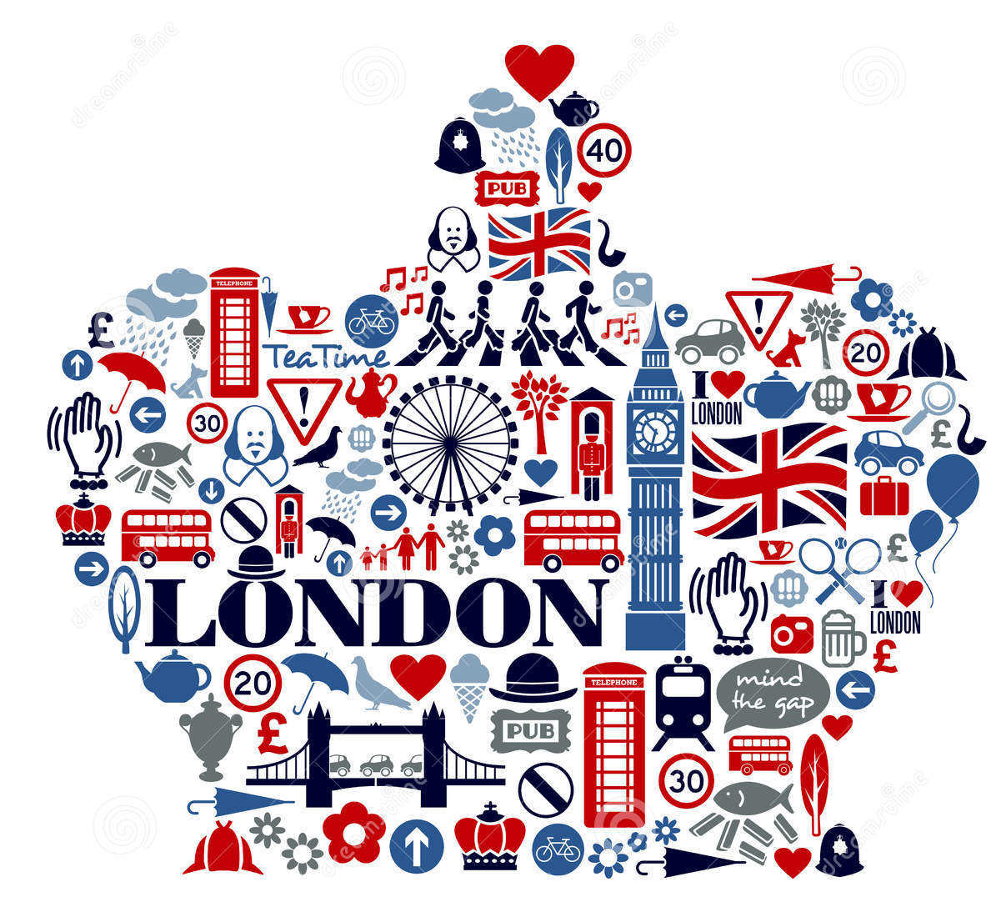
As geographers we will:
• Use the eight points of a compass, four-figure grid references, symbols and keys (including the use of Ordnance Survey maps) to build knowledge of the United Kingdom and the world
• Locate key landmarks in London

As writers we will:
• Non-fiction texts such as biographies (Claude Monet)
• Write in a journalistic style
• Write instructions for our Design and Technology strand
• Write formally for our Mock Election Manifesto

As artists we will:
• Learn about the great artists, architects and designers in history
• Use watercolour paint to produce washes for backgrounds then add detail
• Select and arrange materials for a striking effect (collages)

As mathematicians we will:
• Use the properties of shapes and angles in increasingly complex and practical contexts, including in construction and engineering context
• Practically learn about area and perimeter

As historians we will:
• Complete a local history study – The Tower of London
• We will communicate historically through our learning and understanding of the Tower of London
As scientists we will:
• Continue our study of rocks
• Embed our knowledge and understanding of electrical circuits using Now Press Play and Design and Technology
As designers we will:
• Apply our understanding of how to strengthen, stiffen and reinforce more complex structures
• Understand how key events and individuals in design and technology have helped shape the world
As computers we will:
• Select, use and combine a variety of software (including internet services) on a range of digital devices to accomplish given goals, including collecting, analysing, evaluating and presenting data and information

