More Creative Themes for Learning
Key Stage 1 Geography
Extreme Weather
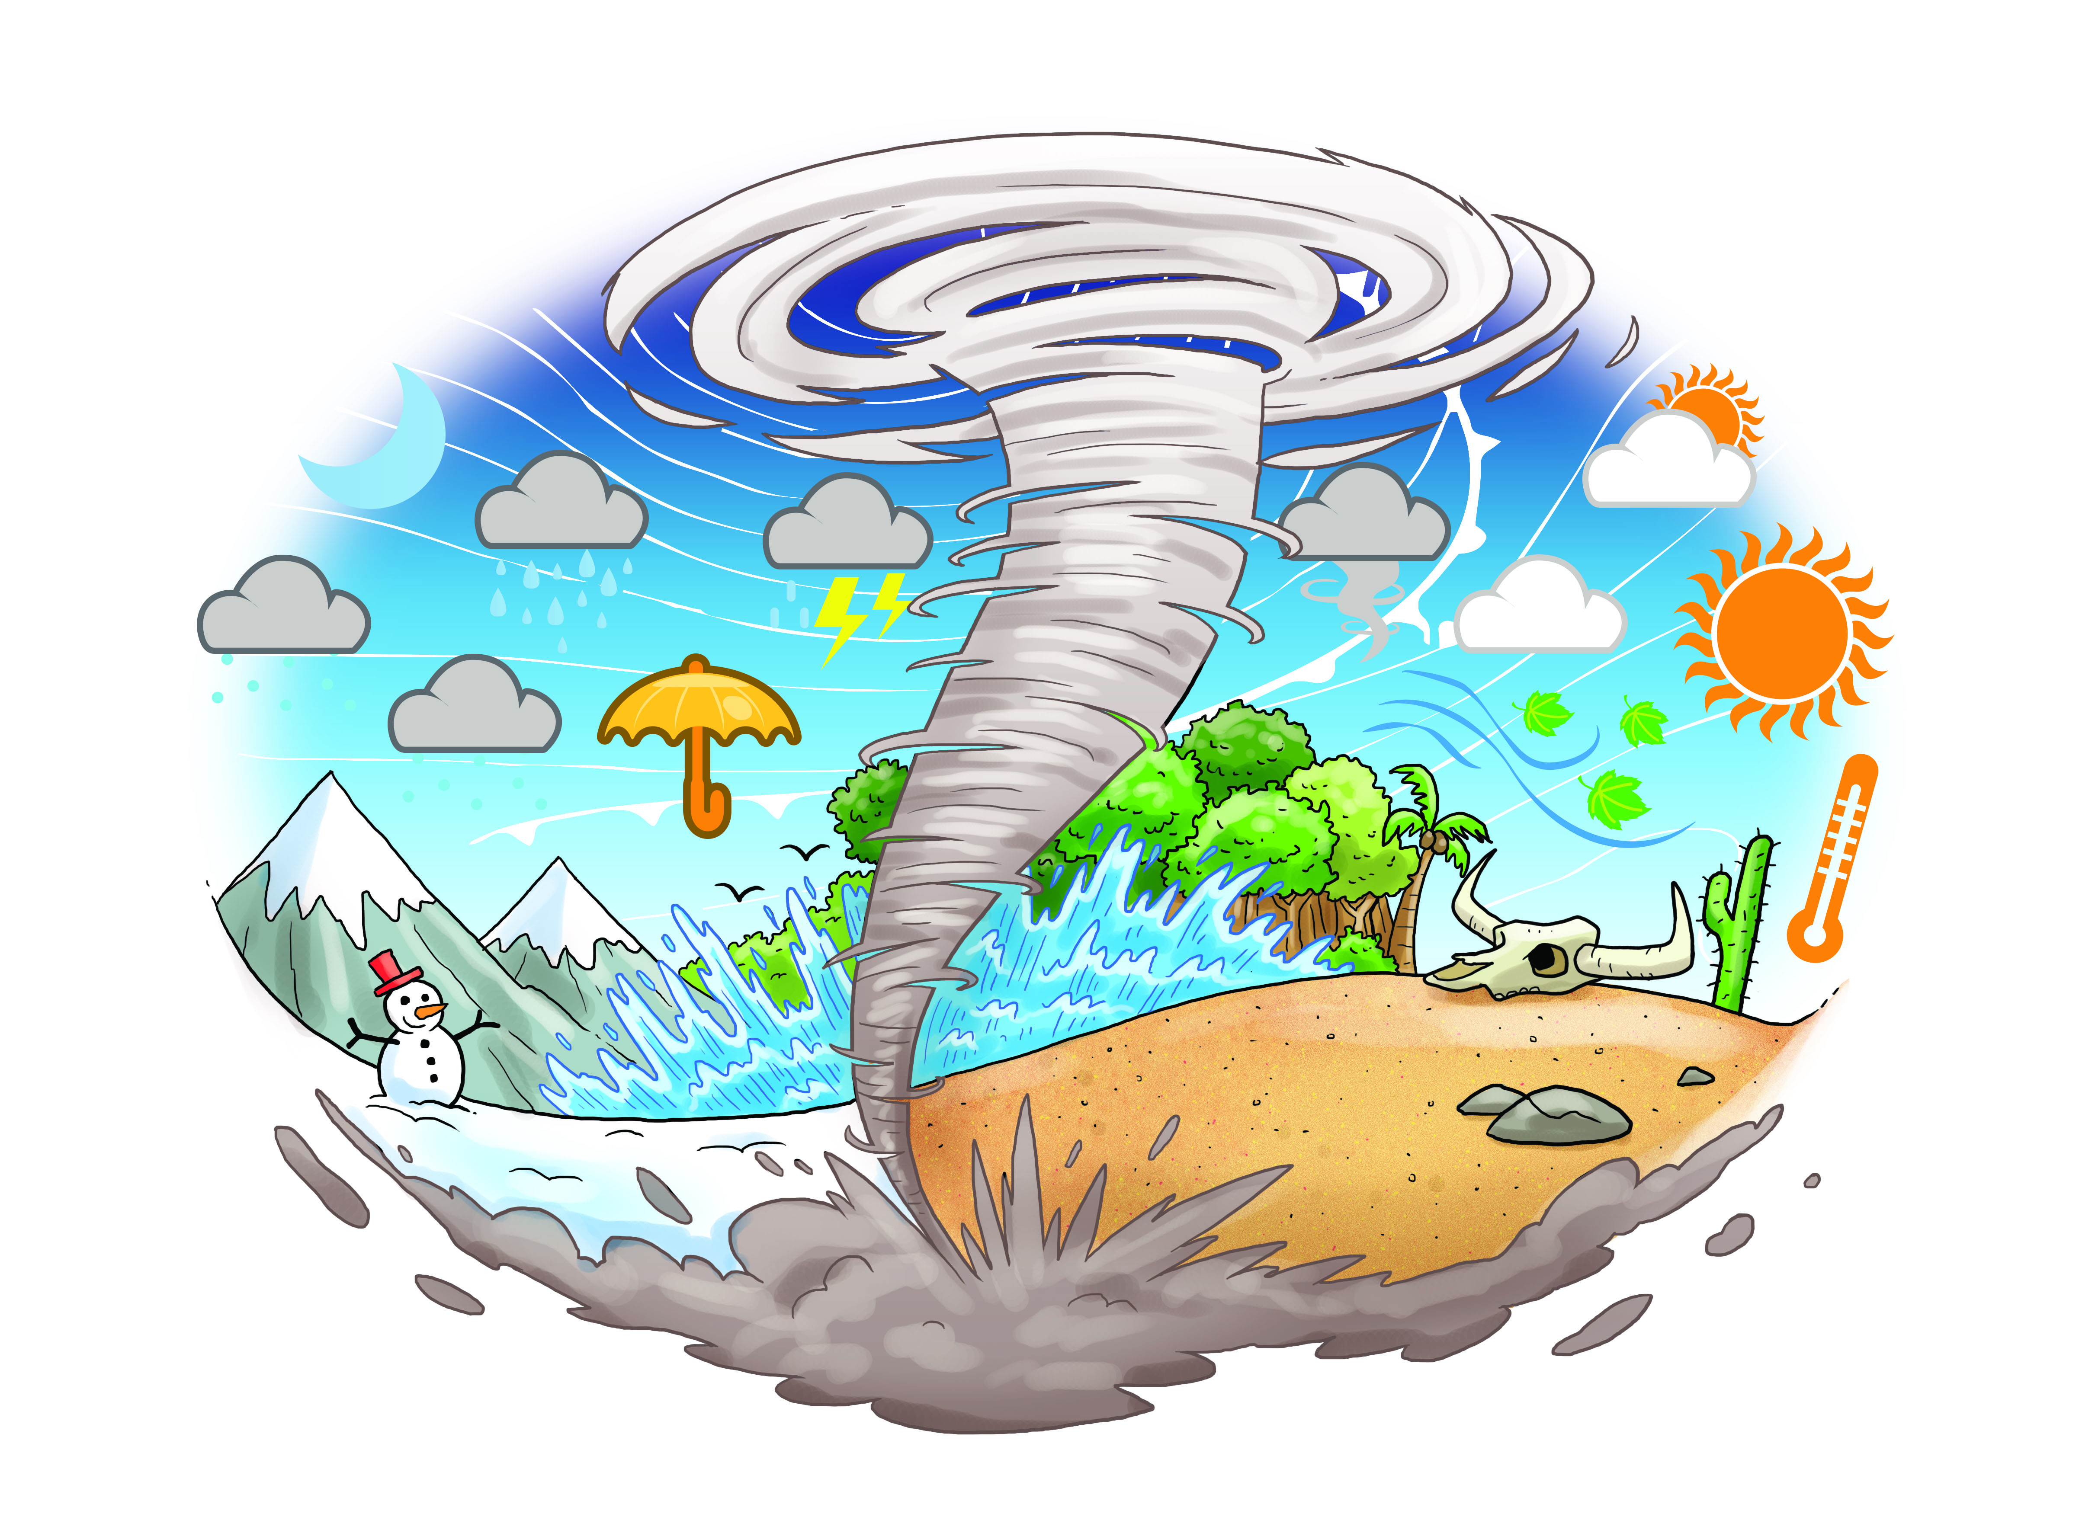
As geographers we will:
• Learn about some of the amazing weather around the world
• Name the continents and oceans
• Practise our geography skills in mapping
• Learn and practise geographical vocabulary
• Identify patterns
• Identify some key features of the places we study

We will watch videos and read about cyclones, tornadoes, snow storms, hot deserts, floods and other incredible weather features.

We will name the continents and oceans and investigate the weather and climate in tropical, temperate and cold places. We will explore the weather and climate in places around the world we have heard of and some new places too.

We will find out about the equator and the tropics, the Arctic Circle and Antarctica.

We will track the weather in some of our favourite places in the world, as well as keeping a chart of the weather at school. We will then use this information to make comparisons.

We will learn about the main cloud types and keep an eye on weather forecasts to see how the weather is affected by the different cloud types.

As scientists we will:
• Observe seasonal changes
• Find out which areas have the same seasons as us and where in the world things are not the same.
• Explore how places in the Southern Hemisphere have the opposite seasons to us
As writers we will:
• Present information
• Write reports
• Produce glossaries
• Write stories
• Write letters
• Create and recite poetry
As artists we will:
• Use collage to create cloud formations
• Draw and paint storms and wreckage
• Use digital media to collect and change pictures of our local weather

As mathematicians we will:

• Add and subtract by comparing temperatures to find the difference
• Collect weather statistics so that we can construct pictograms, tally charts, block diagrams and tables
• Take and record daily temperature and rainfall measurements

