More Creative Themes for Learning
Key Stage 1 Design & Technology
Post a Pringle and other Megastructures
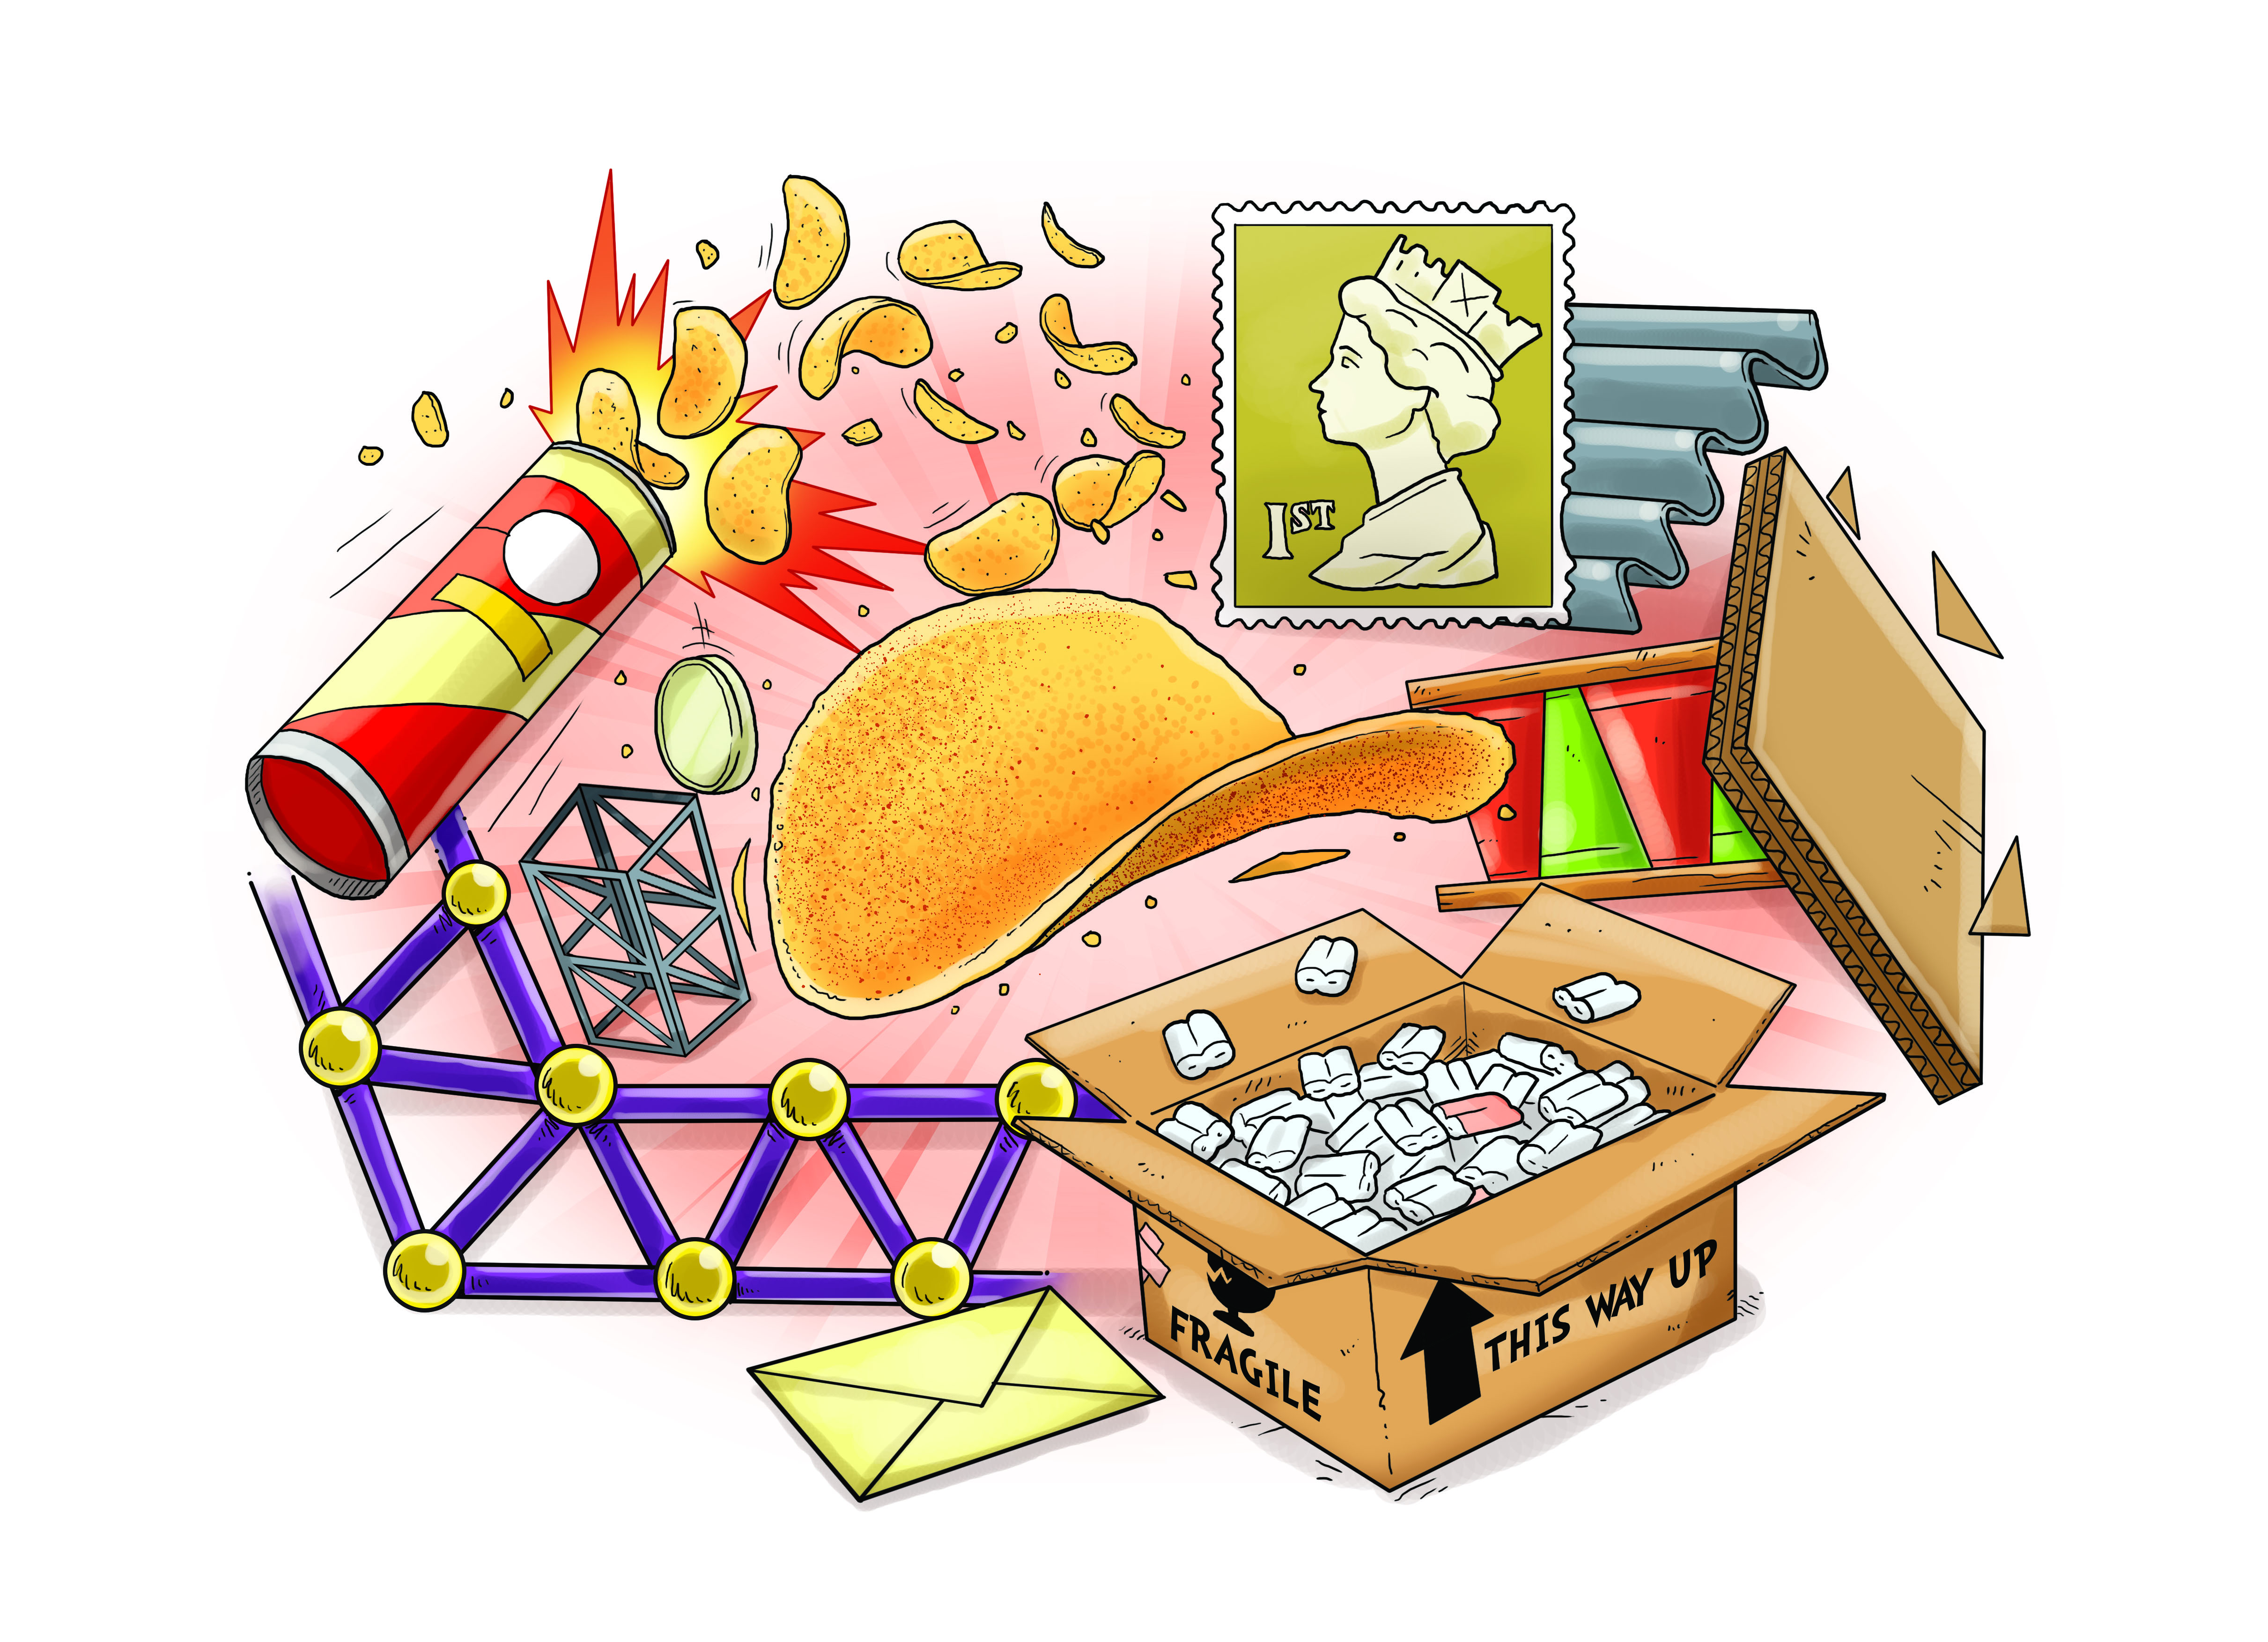
As designers we will:
• Learn about structures
• Discover how to make structures stronger, stiffer and more stable

We will begin our project with a challenge to post a Pringle crisp to school so that it arrives in one piece, with no crumbs! We will need to investigate how to stiffen and strengthen card so that it forms a safe package for our Pringle. We will also need to think about how we can stop the Pringle rattling around in its packet.

We will then move on to investigate how we can strengthen and stiffen everyday materials to create structures. We will find out about rolling paper, gluing strips of wood, strong shapes and weak shapes. We will discover that shapes are very important in building a strong, stiff and stable structure. We will carry out a few class projects, such as the Great Pyramid Challenge and the Great Bridge Challenge where we use lots of pieces of dowel 50cm in length to create our strong, stiff and stable structures.

We will then use our knowledge of structures to build models that we refine and improve. Our final challenge will be the Megastructures Challenge where we will create our own structures, such as towers or bridges.

As writers we will:

• Write explanations about our designs
• Write instructions as to how we created our products
• Present information about how to strengthen materials

As artists we will:

Create photo stories of our designs by using digital media

