More Creative Themes for Learning
Key Stage 1 Design & Technology
From Field to Fork
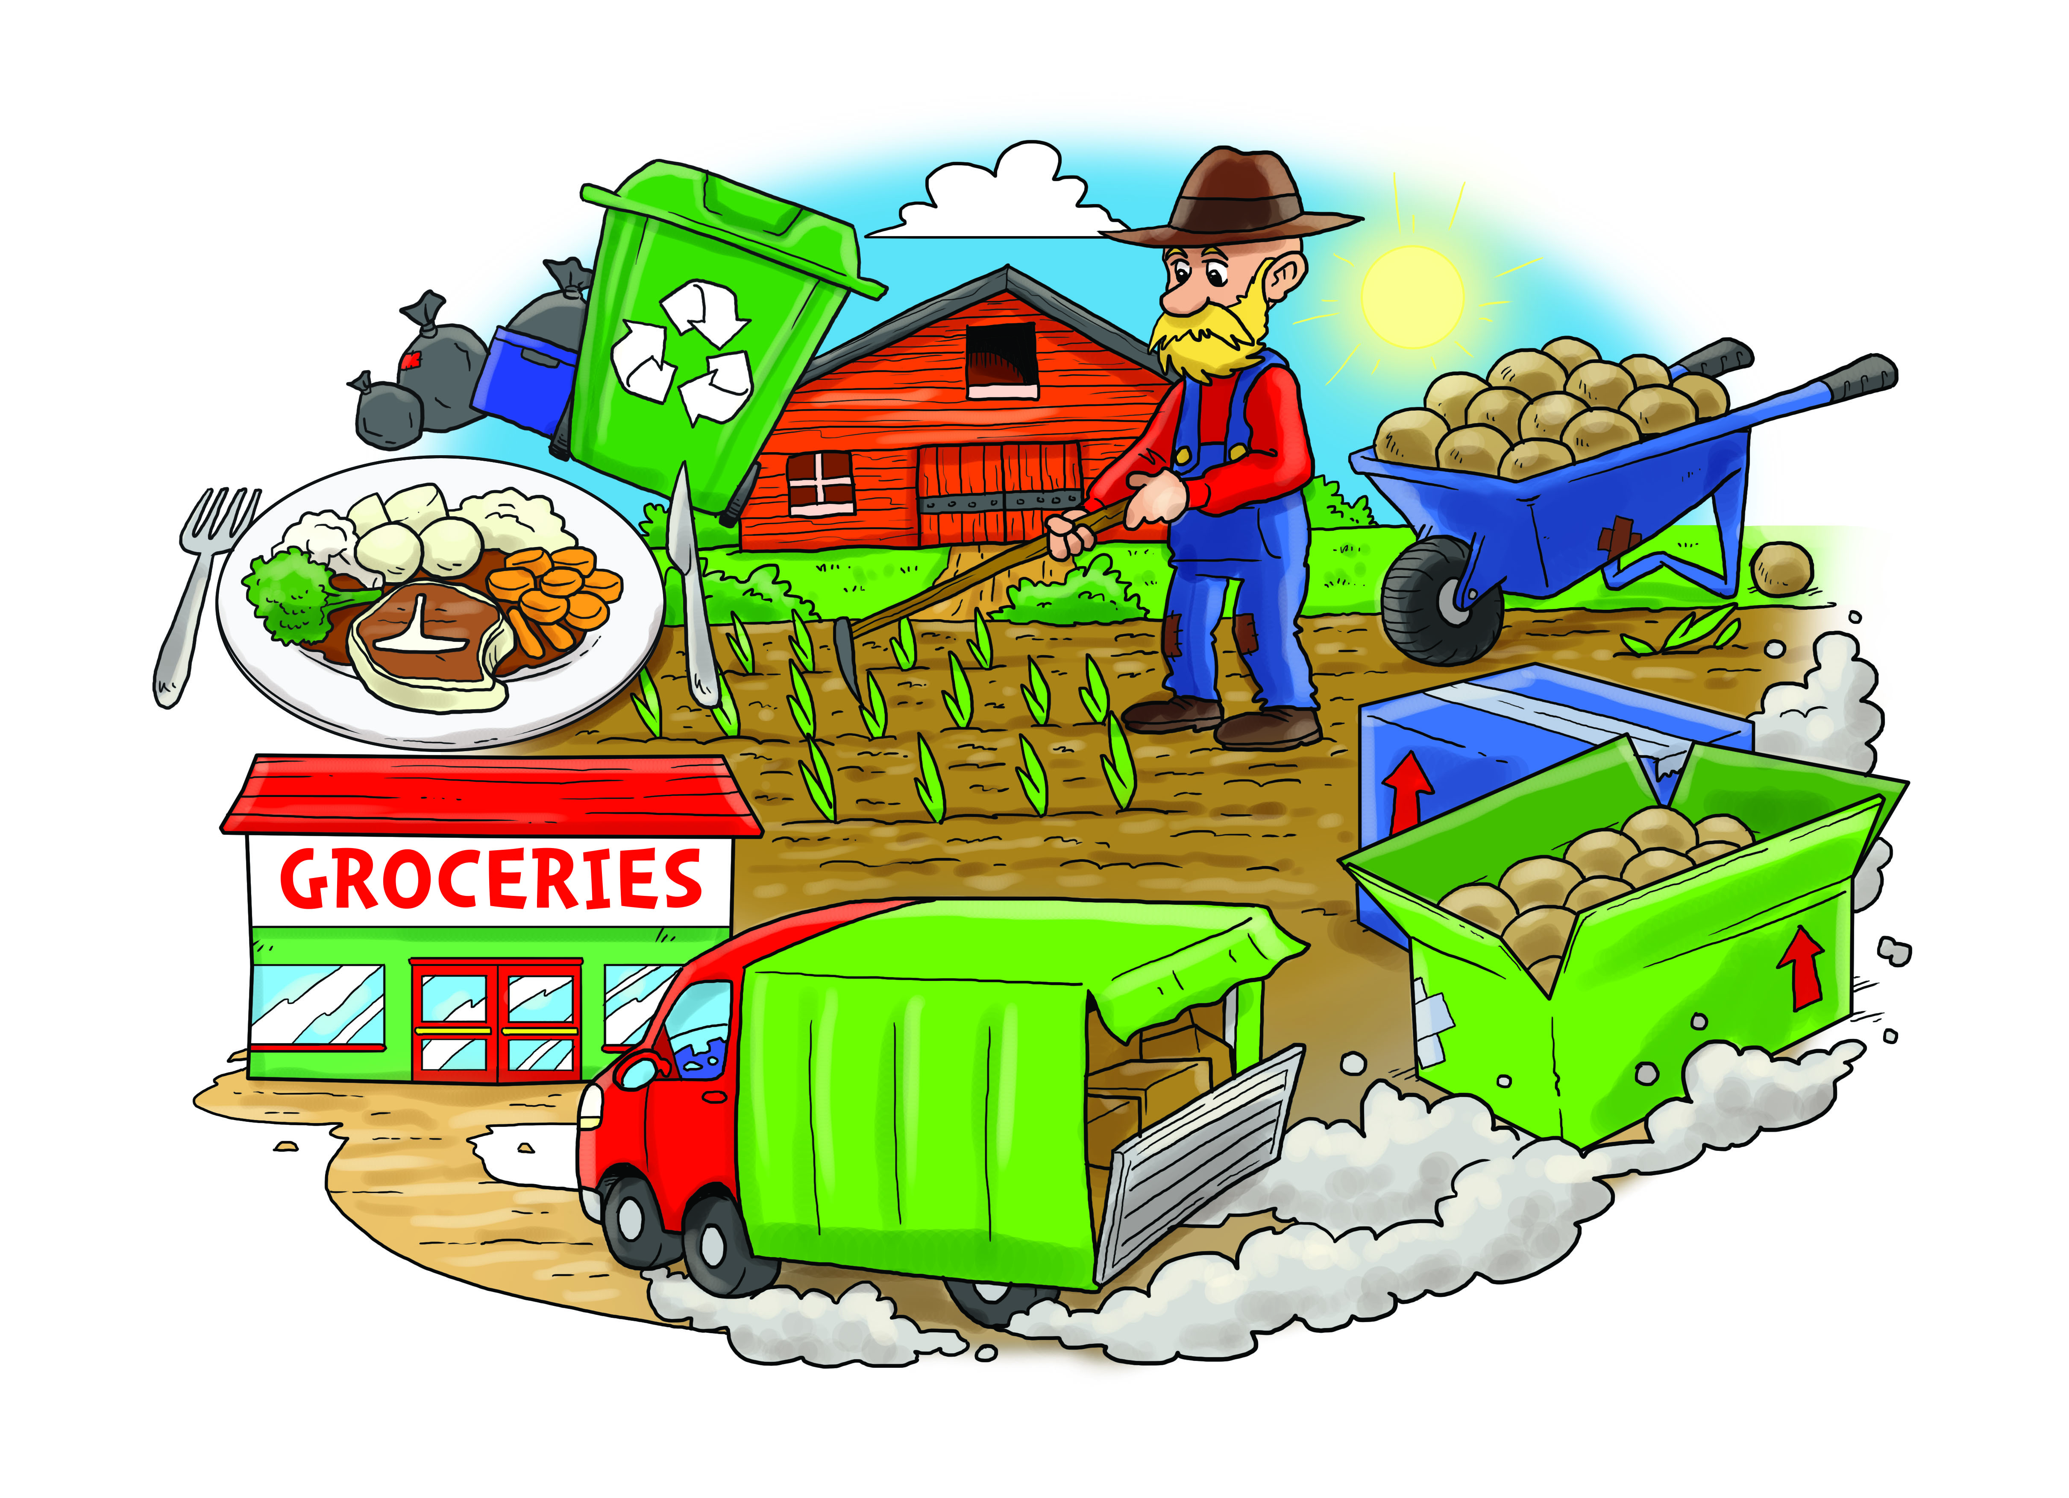
As designers we will:
• Understand where food comes from
• Use the basic principles of a healthy and varied diet to prepare dishes

We will begin by collecting images and samples of some of our favourite foods. We will then discover how food comes from plants or animals and explore how food is farmed, caught or grown. We will also explore some of the changes that happen to food as it makes its journey from the farm to our fork.

We will sort some of the foods that we eat into groups which show which are farmed, caught or grown. We will eat a range of foods, some of which might be new to us, and explore where they come from. Some may be fished, some farmed and some may come from other countries and continents. We will look on maps of the world to track the journey of our food.

We will research fishing and farming in the United Kingdom. We will look at how farmers grow crops, such as potatoes and carrots and how they rear cattle, pigs, chickens and other animals for food. We will find out about harvest time for crops and how this is a very important time of year.

As we look into where food comes from, we will discover how we cannot eat food straight from the farm, the rivers and seas or a field. It has to be changed somehow so that it is safe for us to eat. Sometimes the changes are small and sometimes they are much bigger. To help us to understand this we will prepare some dishes where we will need to wash, peel, cut, and cook. We will also research some everyday foods such as cheese, bread, yogurt, ham, fish fingers and orange juice to understand how food is changed on its journey to our plate.

Throughout our topic, we will have some great fun designing, making and enjoying some hot and cold meals.
As scientists we will:

Plants
• Identify, classify and describe their basic structure
• Observe and describe growth and conditions for growth
Habitats
• Look at environments and food chains
Animals and humans
• Identify, classify and observe
• Look at growth, basic needs, exercise, food and hygiene
As mathematicians we will:
- Practise adding and subtracting quantities in our food preparation
- Practise measuring and reading scales accurately
- Practise using fractions, as we divide quantities of ingredients and portions.
As artists we will:
Develop techniques in drawing, painting and digital media as we collect images and present images of our dishes

As writers we will:

- Present information
- Write reports
- Produce glossaries
- Write stories
- Create and recite poetry

