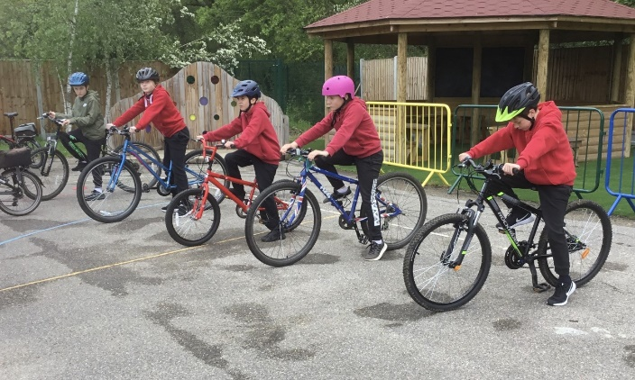

**Outstanding Commitment to**

**HEALTHY SCHOOLS AWARD**

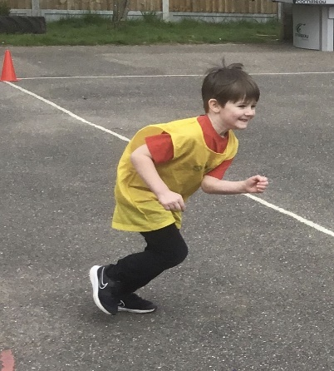

**GOLD**

**Schools Games Mark**

**2020/21**

**£1,149.21 spent on new PE equipment**

**More After school clubs**

**Qualified Sports Coach**

**Links with Basildon Sporting Village for swimming**

**3.5 hours of Curriculum PE each week for all**

**100% of pupils using The Daily Mile**

**90%**

of our Year 6 Swimmers leave achieving their 25m+ certificate.