More Creative Themes for Learning
Key Stage 1 History
Cracking Ideas
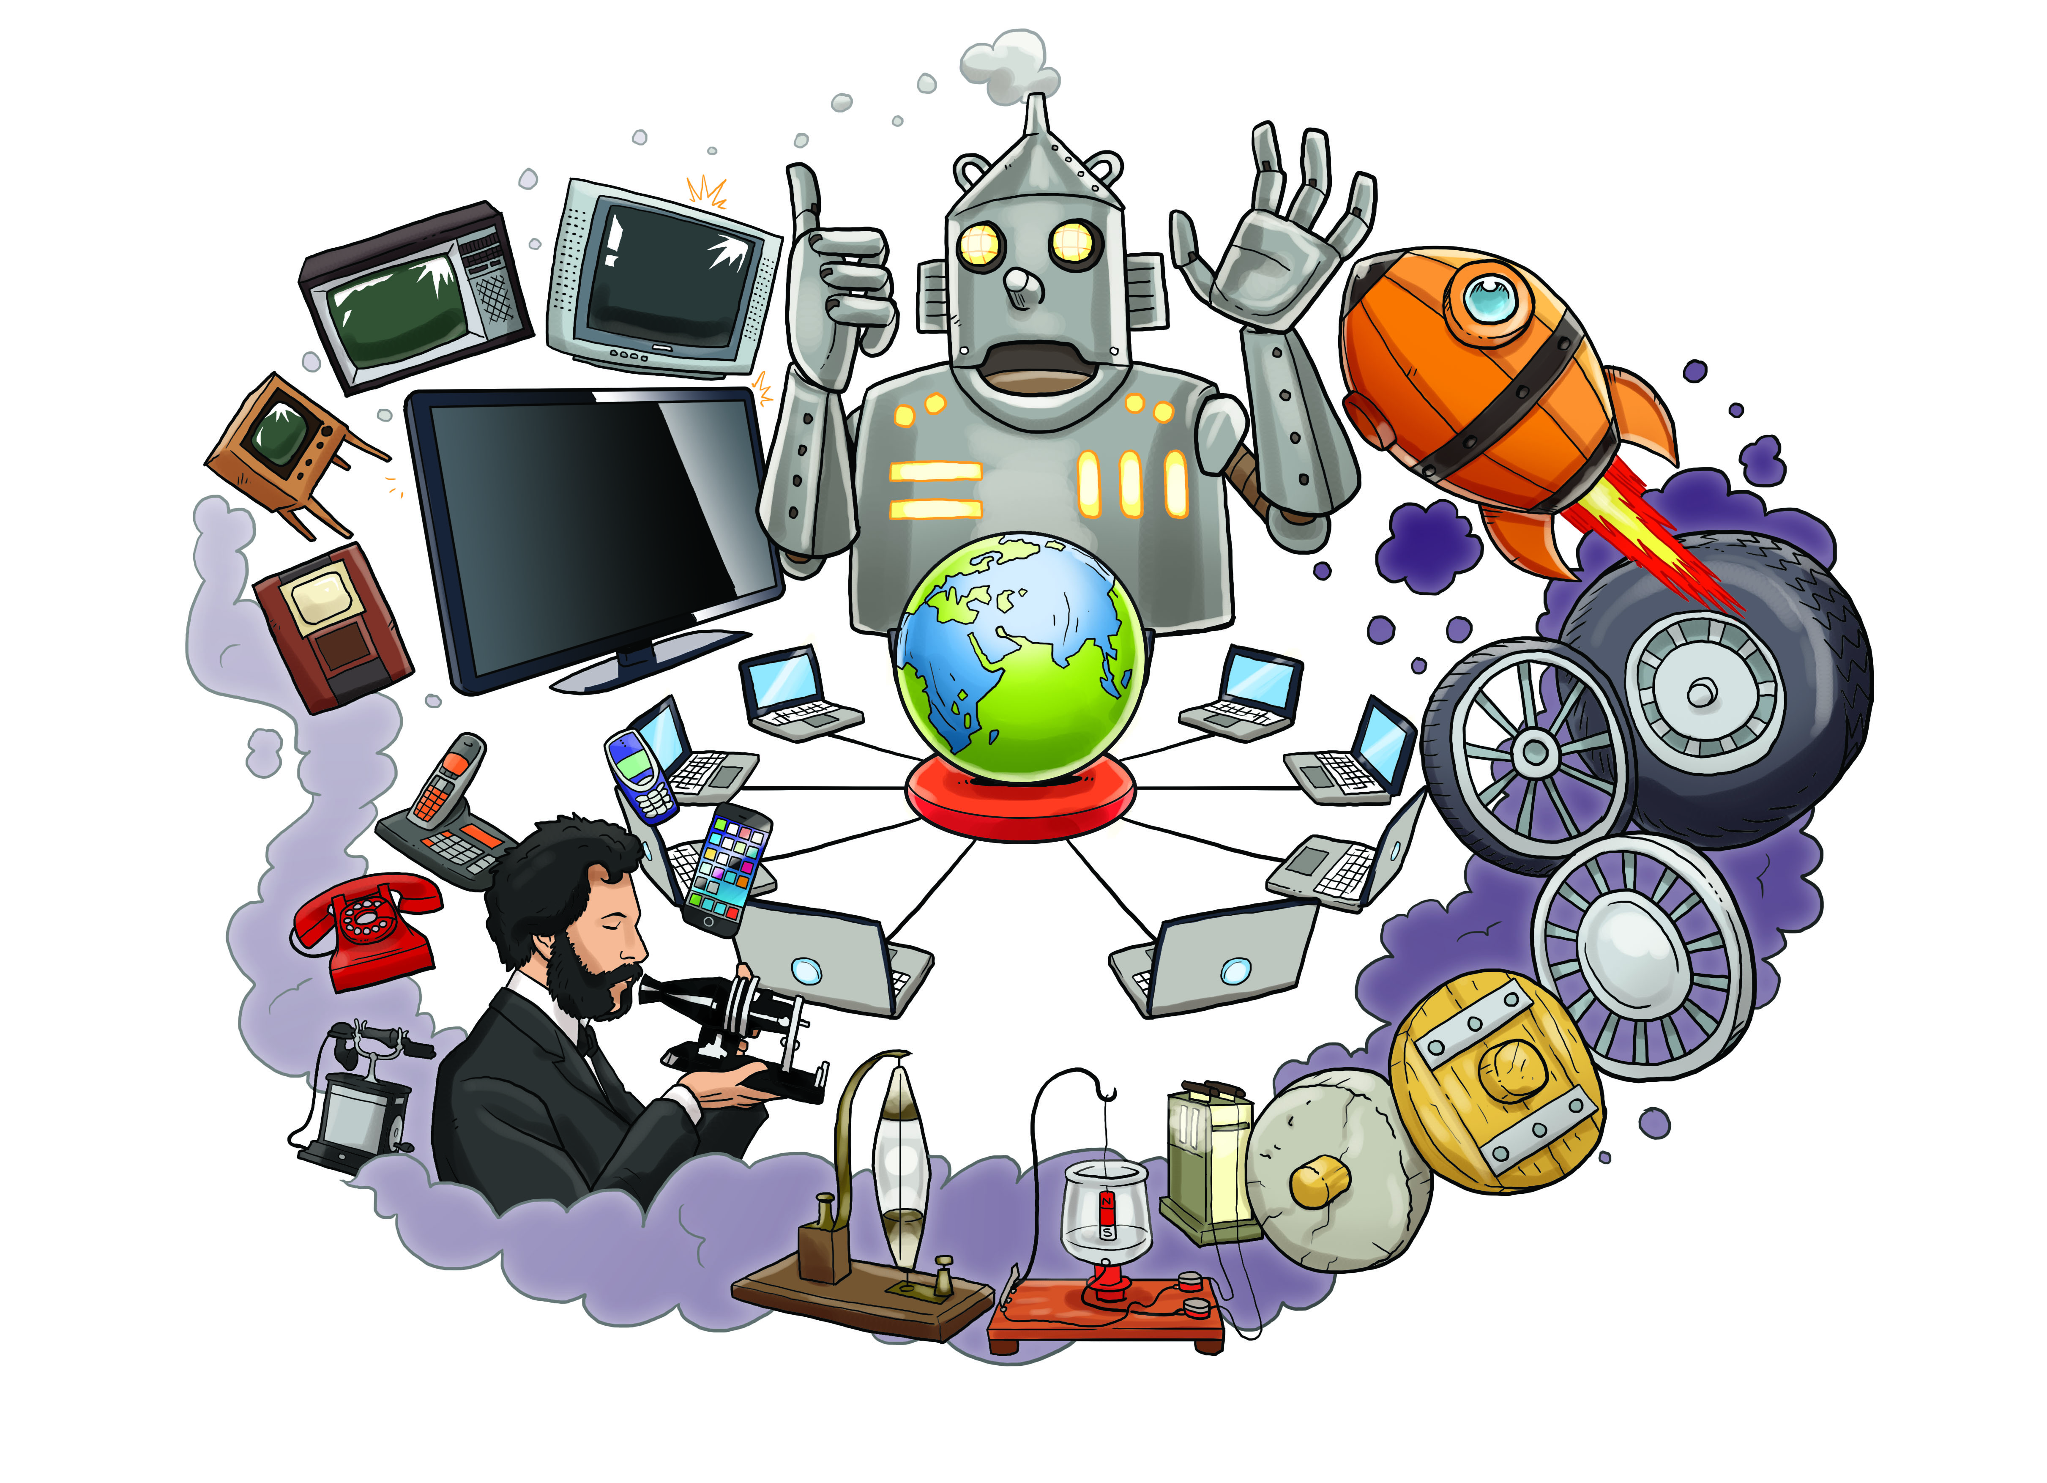
As historians we will:
• Study the lives of significant individuals in Britain’s past
• Study the lives of significant individuals around the rest of the world

We will begin by looking at out some amazing and fun ’cracking ideas’ inventions from the Wallace and Gromit animations. We will also look at some funny and amazing inventions of a Victorian artist called Heath Robinson.

We will find out about how some of the things we use every day started in the
imagination of British scientists, such as:

• The World Wide Web (www) invented by Tim Berners-Lee
• Trains, which began with the steam locomotive invented by Richard Trevithick and the first public railway, built by George Stephenson
• The electric motor, invented by Michael Faraday
• The electric light bulb, invented by Joseph Swan
• The telephone, invented by Alexander Graham Bell
• The television, invented by John Logie Baird
• The jet engine, invented by Sir Frank Whittle
• Digital computers, invented by Alan Turing during World War II to crack
enemy codes
• Computer language, invented by Ada Lovelace for a mechanical computer
invented by Charles Babbage
• Dipped headlights, invented by Emily Canham to stop drivers being dazzled
• Searchlights for spotting enemy aircraft, invented by Hertha Ayrton

We will research some of these inventors and consider how they have had an impact on the world.

As designers we will:
• Design, make and evaluate products
• Build structures and use mechanisms
• Investigate our homes, the school and other places to see if we can come up with ideas and make our own inventions that others may find useful.

As writers we will:
• Write labels
• Write lists
• Write captions
• Write instructions
• Present information
As artists we will:
• Draw and paint images of inventions and their inventors

As mathematicians we will:

• Measure
• Use fractions
• Add and subtract

