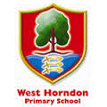
Bespoke Creative Themes for Learning
Art, Geography & Languages
Vive La France
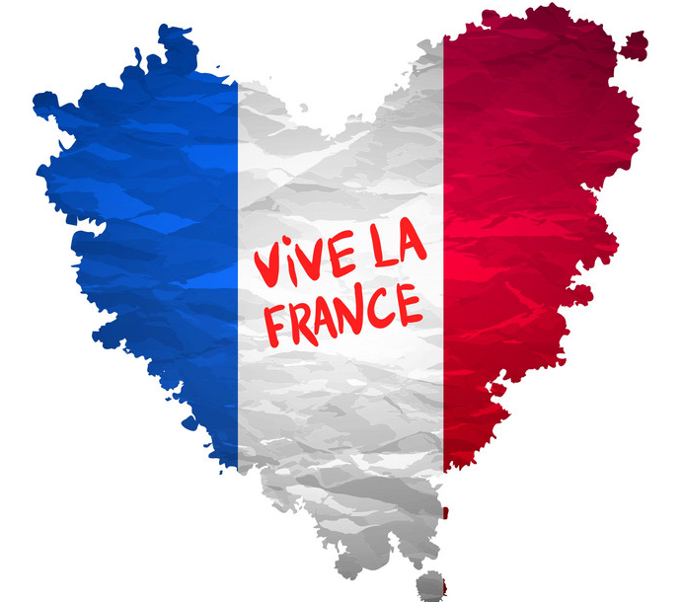
As geographers we will:
• Study the Country of France and the City of Paris
• Compare and contrast France and French Places with locations in the UK

We will find out about some of the regions, cities, landmarks and wildlife.

We will start by looking at maps of France (Europe and the World) so we can see where it is and name some towns and cities.

- History of the French flag ( Tricolore).

We will then focus our studies on France, looking at:

Physical features:
• Some of the amazing landscapes, wildlife and plant life of the mountains, rivers and coastline.
• The mountain ranges of the Alps and the Pyranees
• Some of the rivers, such as the Seine, Loire and the Rhone

We will compare and contrast some of these features with those in the United Kingdom

Human features:
• The regions, towns and cities, focusing on landmarks – The Eiffle tower, Lourve, Rouen Cathedral, Notre Dame, Arc De Triumph, palace of Versailles, the metro.

We will study some of the regions across France discussing compass points.

We will compare and contrast some of these features, events and people with those in the United Kingdom.

As writers we will:
- Present information
- Songs / poems
- Write Nonfiction texts – travel brochure / leaflet/ non- chronological report.
- Create stories and other narratives
- Learn about some the writing of some of Frances significant authors- Victor Hugo- Hunchback of Notre Dame.

As artists we will:
• Draw and paint images of the landscapes and cities we study.
•To master techniques – painting / brushes / water colour/ tones and tints/ drawing lines of different thickness.
• Take inspiration from some of France’s great artists such as Monet and Matisse.
- Sculptures by Augustus Rodin.

As mathematicians we will:
• Calculate time by exploring journey times from the UK to different parts of France and by looking at the time difference between the UK and France
• Use statistics by exploring data about rivers and bridges.
- Shapes in buildings – Rouen Cathedral / Lourve / Notre Dame

As linguists we will:
- Learn key French vocabulary including greetings, numbers, body parts, animals, family members, colours, buildings and how to introduce yourself.
- be able to hold simple conversations
- Begin to be able to write simple sentences in French such as my name is, daily mile numbers and days of the week.

As sportsmen we will:

- Learn about and play some traditional and significant French sports and pastimes including:
  - Boules (petanque)
  - The history and route of the Tour de France
  - The location and names of significant French Football teams
  - The history and significance of the French Open Tennis tournament as one of the four Grand Slam events.
  - Sports day teams- French sports people.

As Musicians we will:

- Listen to and appraise the music of some significant French composers and musicians including Ravel, Debussy, Jean Michel – Jarre, Edith Piaf and David Guetta.
- French songs – alloutte and Frère Jacques.

As chefs we will:

- Taste, learn about the history of and how to cook traditional French dishes such as ratatouille, camembert, crepes, cheese soufflé and snails.

